# K8s及基础组件自动化部署方案-ansible版

## 一、软硬件环境要求

1.1硬件环境需求：

应用于生产，基础组件安装需要准备至少10台。

|  |  |  |  |  |  |  |
| --- | --- | --- | --- | --- | --- | --- |
| 主机名 | Centos版本 | docker version | flannel version | keepalived version | 主机配置 | 备注 |
| lvs-keepalived01 | 7.5桌面版 | / | / | v2.0.11 | 4C4G | 必需 |
| lvs-keepalived02 | 7.5桌面版 | / | / | v2.0.11 | 4C4G | 必需 |
| master01 | 7.5桌面版 | 1.13.1 | v0.7.1 | / | 4C8G | 必需 |
| master02 | 7.5桌面版 | 1.13.1 | v0.7.1 | / | 4C8G | 必需 |
| master03 | 7.5桌面版 | 1.13.1 | v0.7.1 | / | 4C8G | 必需 |
| work01 | 7.5桌面版 | 1.13.1 | v0.7.1 | / | 根据实际需求 | 必需 |
| work02 | 7.5桌面版 | 1.13.1 | v0.7.1 | / | 根据实际需求 | 可扩展 |
| work03 | 7.5桌面版 | 1.13.1 | v0.7.1 | / | 根据实际需求 | 可扩展 |
| VIP | / | / | / | / | / | 在lvs-keepalived两台主机上浮动 |
| client | 7.5桌面版 | / | / | / | 4C8G | 必需 |
| harbor | 7.5桌面版 | 18.09.1 | / | / | 4C4G | 必需 |
| ingress01 | 7.5桌面版 | 1.13.1 | v0.7.1 | / | 4C8G | 必需 |
| ingress02 | 7.5桌面版 | 1.13.1 | v0.7.1 | / | 4C8G | 必需 |

## 二、软件版本说明

2.1部署的软件版本说明

|  |  |
| --- | --- |
| 名称 | 版本 |
| K8s及基础组件部署包（ansible） | 1.0.0_20200526 |

## 三、前期准备

1、拷贝文件ansible_basic_{{版本号}}.tar.gz到k8s_master01服务器/etc目录下

2、解压文件ansible_basic_{{版本号}}.tar.gz：

执行：tar -xvzf ansible_basic_{{版本号}}.tar.gz -C /etc

3、安装ansible

执行：sh /etc/ansible_basic/roles/init/files/init0.sh

安装pexpect-4.8.0时报错：

transport, pw = yield from asyncio.get_event_loop()\

解决方法：

python

import pexpect

如上指令正常说明无问题，可进行下一步

4、验证ansible是否安装完成：如下界面为正常安装

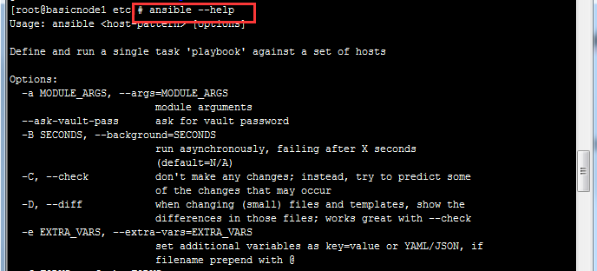

5、配置文件/etc/ansible/roles/init/files/init.txt

1)理论上修改部署ip即可

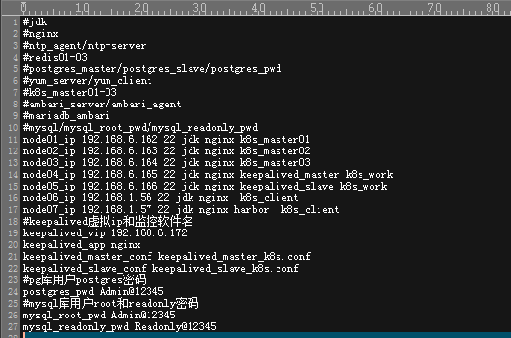

2)修改keepalived虚拟ip，必须为未被占用



6、初始化

执行：sh /etc/ansible_basic/roles/init/files/init1.sh

7、免密登陆：

执行：

cd ~/.ssh

ssh-keygen -t rsa

ansible -i /etc/ansible_basic/hosts jdk -m authorized_key -a "user=root state=present key=\"{{ lookup('file', '/root/.ssh/id_rsa.pub') }} \"" –k

8、执行初始化（停止防火墙及selinux）

执行：cd /etc/ansible_basic/ && ansible-playbook -i /etc/ansible_basic/hosts /etc/ansible_basic/init.yml

## 四、部署k8s

**本地镜像仓库部署：**

执行：cd /etc/ansible_basic/ && ansible-playbook -i /etc/ansible_basic/hosts /etc/ansible_basic/harbor.yml

**K8s集群部署：**

执行：cd /etc/ansible_basic/ && ansible-playbook -i /etc/ansible_basic/hosts /etc/ansible_basic/k8s.yml

**K8s创建客户端：**

执行：cd /etc/ansible_basic/ && ansible-playbook -i /etc/ansible_basic/hosts /etc/ansible_basic/k8s_client.yml

**K8s部署ingress：**

执行：cd /etc/ansible_basic/ && ansible-playbook -i /etc/ansible_basic/hosts /etc/ansible_basic/k8s_ingress.yml

## 五、基础环境部署

**部署nginx：** 该步骤会清理掉nginx已有配置,操作请注意

执行：cd /etc/ansible_basic/ && ansible-playbook -i /etc/ansible_basic/hosts nginx.yml

**部署yum源：** 预计耗时8分钟

拷贝yum源文件到yum_server服务器上：mkdir -p /etc/nginx/www/html

执行：cd /etc/ansible_basic/ && ansible-playbook -i /etc/ansible_basic/hosts yum_server.yml

**部署yum客户端：**

执行：cd /etc/ansible_basic/ && ansible-playbook -i /etc/ansible_basic/hosts yum_client.yml

**部署jdk：**

执行：cd /etc/ansible_basic/ && ansible-playbook -i /etc/ansible_basic/hosts jdk.yml

**部署pg：**包括pg主从及单节点的部署

执行：cd /etc/ansible/ && ansible-playbook -i /etc/ansible_basic/hosts pg.yml

**部署mysql：**

执行：cd /etc/ansible_basic/ && ansible-playbook -i /etc/ansible_basic/hosts mysql.yml

**部署mariadb：**

执行：cd /etc/ansible_basic/ && ansible-playbook -i /etc/ansible_basic/hosts mariadb.yml

**部署keepalived：**

执行：cd /etc/ansible/ && ansible-playbook -i /etc/ansible_basic/hosts keepalived.yml

**部署redis：**

执行：cd /etc/ansible_basic/ && ansible-playbook -i /etc/ansible_basic/hosts redis.yml

**部署ntp：**

执行：cd /etc/ansible_basic/ && ansible-playbook -i /etc/ansible_basic/hosts ntp.yml

## 六、Dashboard配置为用户密码登陆

**创建用户文件（密码,用户名,用户id#不可重复） --所有master**

echo 'admin,admin,1' > /etc/kubernetes/pki/basic_auth_file

**修改配置 --所有master**

vim /etc/kubernetes/manifests/kube-apiserver.yaml

# 增加如下参数

- --basic-auth-file=/etc/kubernetes/pki/basic_auth_file

**重启api-server --所有master**

[root@master manifests]# pwd

/etc/kubernetes/manifests

[root@master manifests]# mv ./kube-apiserver.yaml ../

[root@master manifests]# mv ../kube-apiserver.yaml ./

**将用户与权限绑定**

kubectl create clusterrolebinding login-on-dashboard-with-cluster-admin --clusterrole=cluster-admin --user=admin

**查看绑定**

kubectl get clusterrolebinding login-on-dashboard-with-cluster-admin

**修改kubernetes-dashboard.yaml,开启authentication-mode=basic配置**

args:

- --auto-generate-certificates

- --namespace=kubernetes-dashboard

- --token-ttl=43200

- --authentication-mode=basic

**更新kubernetes-dashboard**

kubectl apply -f kubernetes-dashboard.yaml

## 七、故障处理

**集群服务器重启，集群所有节点会自动恢复**

**master节点异常需要重新加入集群（以master03异常为例）**

1、删除master节点

kubectl drain master01

kubectl delete node master01

2、登陆正常master01，删除etcd信息

#kubectl exec -it etcd-master01 sh

#etcdctl --endpoints 127.0.0.1:2379 --cacert /etc/kubernetes/pki/etcd/ca.crt --cert /etc/kubernetes/pki/etcd/server.crt --key /etc/kubernetes/pki/etcd/server.key member list

上述指令结果如下：

7d39fc3ab8790afc, started, master03, https://192.168.0.93:2380, https://192.168.0.93:2379, false

b54177b91845ab93, started, master01, https://192.168.0.91:2380, https://192.168.0.91:2379, false

bc771924f2f5445f, started, master02, https://192.168.0.92:2380, https://192.168.0.92:2379, false

3、删除master03的etcd信息

etcdctl --endpoints 127.0.0.1:2379 --cacert /etc/kubernetes/pki/etcd/ca.crt --cert /etc/kubernetes/pki/etcd/server.crt --key /etc/kubernetes/pki/etcd/server.key member remove 7d39fc3ab8790afc

4、修改k8s_master_recover.yml

- hosts: master01

roles:

- {role: k8s_join}

tags:

- k8s_join

- hosts: master03

roles:

- {role: k8s_master_recover}

tags:

- k8s_master_recover

5、master03重新加入集群

ansible-playbook -i hosts k8s_recover.yml --tags='k8s_join'

ansible-playbook -i hosts k8s_recover.yml --tags='k8s_master_recover'

ansible-playbook -i hosts k8s.yml --tags='k8s_realserver'

**work节点异常需要重新加入集群**

keepalived全部挂掉，客户端服务器无法访问集群，master服务器由于配置有回环ip均可以正常访问集群

**master或者work节点服务器不应是虚拟ip所在服务器，会导致该节点异常。**